The Pawprint |  |  |  |  | Early Spring Edition 2015
Straughn Middle School
Looking Ahead:
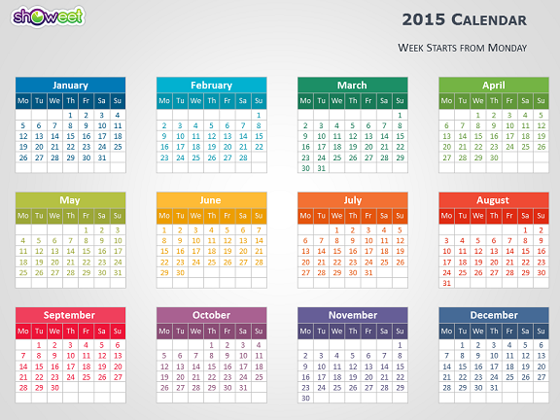

March 5
8th Grade to LBW
“ Our Town”
Mrs. Alabama
March 6 Box Top Bash
March 11 SHS Concert
Band @
Enterprise
March 18 Spring Pictures
March 19 Report Cards
March 20 Cheerleader
Tryouts
March 30 Spring Break
Begins

April 14-16 ACT Aspire Testing
April 23 Fun Day
April 24 Student Break/
Weather Day
April 27 Spring Football
Training Begins
April 30 Elementary Math
Tournament (6th )

May 1 Middle School
Math Tournament
Dodge Ball
Tournament
May 8 Talent Show
May 14 Arts Festival
May 19 History Bee
May 21 AR Field Trip
Camp
Butter & Eggs
May 22 8th Grade Day
May 25 Holiday
May 27 Awards Program
May 28 Last Day for
Students/ Report
Cards

What's Happening! by Paula Simpson 6th Grade Reading teacher
This year has certainly flown by! The time has come for pageants, showcases, and try-outs just to name a few.
The annual Black History program will be this year on February 24th. The theme this year is A Century of Black Life, History and Culture. The students have been preparing songs, art work, videos and recitations in preparation for this event. There will be a speaker this year speaking on tolerance. This a free and public event sponsored by our school.

Along with ball try-outs and band auxiliary try-outs, there will also be cheer try-outs. The SMS JV cheer squad will be holding cheer clinic March 16-19 with try-outs being held at 2:00 p.m. on the 20th for any 6th or 7th grade girl interested. All forms and fees are due by March 3, 2015. For more information contact Paula Simpson or Lee Lumpkin.



Letters From Home By: Mr. Wood

Students from Straughn Middle School shared the holiday spirit with deployed service men and women in Afghanistan before Christmas. The middle school students collected items to send overseas in addition to writing letters thanking them for their service and wishing them a Merry Christmas. Plastic shoeboxes were filled with toiletries, socks, candy, beef jerky, razors, hand-warmers and assorted items the students thought the soldiers would enjoy. They also coordinated with Mrs. Cobb's second grade class and included letters from the holidays and thoughts of thankfulness.

Ellie Guilford wrote "Thank you for spending your Christmas overseas so I could spend mine here in safety." Laura Lea Blatz wrote about her life and the people that influenced her and how she admired the soldiers. She included how blessed she was to wake up in her country in safety everyday because of their service. She closed with "May God be with you and your family."
Straughn Middle School encourages its students to participate in service projects as a whole, but this project was personal. The students all felt a sense of pride in knowing somewhere on the other side of the world, a soldier was

learning a little about them, enjoying a treat, and most of all, learning just how thankful the students were for the service-members and their families sacrifice during the holiday season.

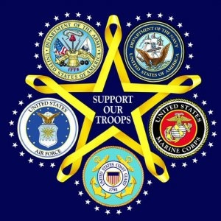

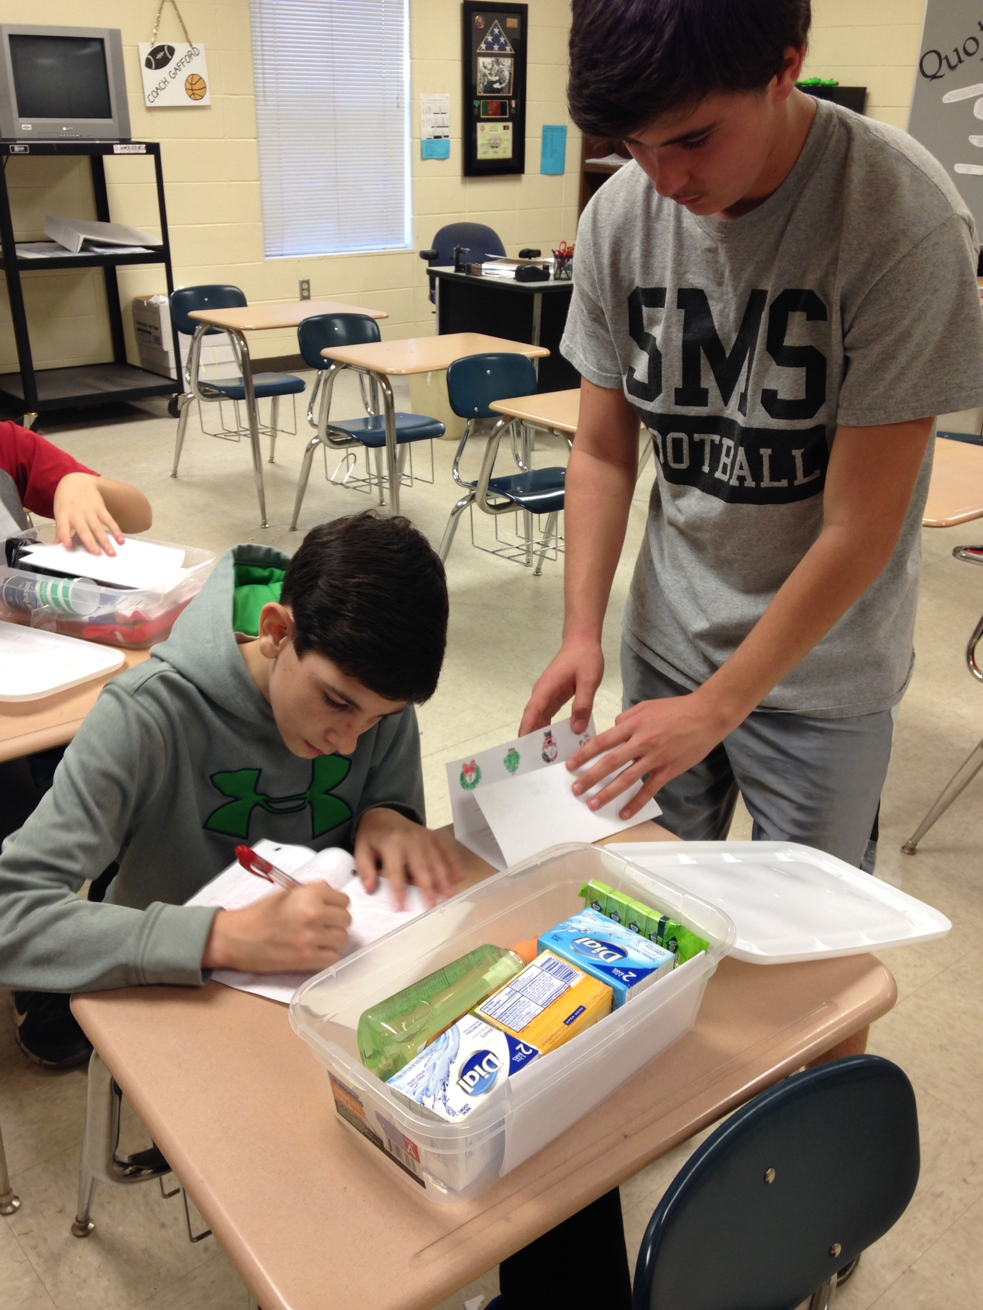
Samuel Driver and Isaiah Smith
Prepare boxes
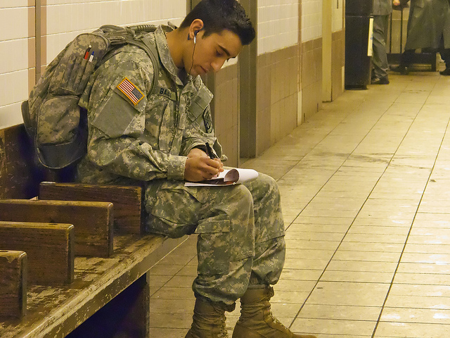
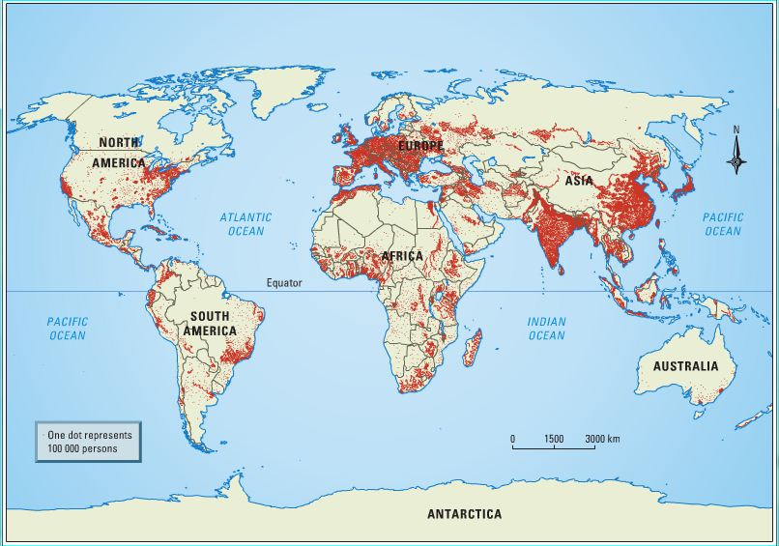
7th Grade GEOGRAPHY

7th Grade GEOGRAPHY
 | By: Karen Ziglar 7th Grade SS      Our Geography class has been very busy since they came back from Christmas break. We have been learning about what geography is and what geographers do. We have learned about landforms, erosion, the water cycle, Earth’s growing population, and that different people have different cultures. We have been using our globes to find countries and continents on Earth.  We learned latitude and longitude and completed a really cool Google Earth activity. Our first project of the semester was about our hometown of Andalusia. We used the information we had learned in the first three chapters of our geography book to find information about our hometown, and then we created flyers to tell about what we had learned.  There will be more projects to come this semester as we learn about the culture of different countries. Ask your student what he or she is learning in Geography.  Our History Bee will be on Tuesday, May 19, 2015. Please watch for more information. If your child is interested in participating, there will be a sign up time in the near future.  Hey Batter Batter  By: Ms. Osborn  The Straughn Lady Tigers came back from the Christmas Break eager to get on the field. We worked on building our arm strength for the first two weeks of practice, during our throwing period. For the last two weeks of practice, it has been perfect weather for the girls to get many things accomplished. The JV Straughn Lady Tigers Softball team has been working very hard on and off the field. We have spent many hours working on various skills and perfecting even the small things. The girls have three great coaches; Kenny Skipper, John Fussell, and Shanda Osborn. Each coach expects nothing but the best from each young lady. Each day, they complete many different drills to perfect their fielding and hitting. We have worked hard on bunt coverages and situational drills. Each girl strives to get better and better each day and it is very evident that they have improved since day one. The Lady Tigers start their season off on February 26 as we play the Opp Bobcats in a double header in Opp. They will also be playing in the Opp Tournament on February 27th. We hope that everyone will come out and support the Lady Tigers this season! |  |  |  |  | Straughn Middle School held its annual Beauty Pageant on January 31, 2015. Congratulations to Miss Laura Lee Blatz who was crowned Miss SMS 2015. Miss congeniality was Kristen Brazwell. Emmy Rabren placed as 8th grade 1st alternate and 2nd alternate was Taylor Johnson. 7th grade beauty was Miss Emmaleigh Ray, along with 1st alternate Emilee Waite and 2nd alternate Cambry Scott. 6th grade beauty went to Miss Kayleigh Ray . 1st alternate was Kelly Watson and Julie Bryan received 2nd alternate.  Each Grade also named photogenic winners. They were: 8th grade, Emmy Rabren; 7th grade Cameron Stephens and 6th grade Miss Photogenic was Julie Bryan.  Congratulations to all of the 2015 participants. The SMS Council thanks everyone who came out to support their pageant. It is with fundraisers such as this pageant that they are able to fund various projects for SMS.  
 | s

